**Question 1**

1. Design an architecture which incorporates the following client needs. The clients know that his whole setup is going to evolve constantly. Include a cloud formation template for programmable infrastructure for your design. Needs to be scalable and flexible Needs to have low latency for SEO purposes Needs to be cost effective

Comments - Preparing the initial set up for Demo - The presentation contains the initial architecture draft of the problem. The cloud formation template is Initial_Template.json . I have created a sample Website to demonstrate the demo . The website is coded in php and also contains a .sql file which needs to be uploaded to the MY SQL DB. In the initial phase of the assignment , I had limited knowledge on hosting website . Hence I did some research and selected XAMPP V3.2.4 (which is a open source webserver solution) .The website contains login page and Product page (which allows user to enter product detail, upload thumbnail , video and image).

Requirement Analysis

1. The web shop is hosted on e-commerce tool Magneto. Did some research and found Magneto v2.1.2 is compatible with DB MySql V 5.7.X
2. The RDS set up in AWS needs to be scalable and flexible ( MultiAZ set up and configuring MasterDB and Replica DB). I did some investigation and found Amazon Aurora MySQL DB is compatible with MYSQL and flexibility to control autoscaling, low latency and is cost effective. However this solution needs to tested with the Magneto tool. In Aurora MYSQL DB we can use the below paraments in the Cloud Format template to enable autoscaling after the DB usage crosses a particular threshold.
   1. *** In the initial design , I have created master and Replica MySQL DB. – Refer to **Q1Cloudformation_Attempt1.json**
3. I analysed the problem statement and realised CloudFront can be used to perform low latency for SEO purpose.However for the assignment , I need to create a EC2 instance where I will be hosting the WebServer and establishing a connectivity with RDS instance.

***NOTE - Refer to the section **Final Architecture design for the set up** where I have shown the how to make the RDS DB set up scalable ,flexible and enable low latency for SEO purposes.

Steps to migrate MYQSL DB to RDS -

1. This can be done using , AWS Database Migration Service or by using MySQL Workbench tool. For my demo I used the MYSQL dump and imported to the RDS MYSQL Db using MYSQL workbench. I have also gone through the steps mentioned in AWS DB migration service.

**Question 2**

1. After releasing the new architecture, business takes on, and the client decides to add customer reviews. Do you need to alter your architecture? And if so, how?

Comments - TO add customer review , there need not be any change in the architecture , however this would require a additional Table in the Database instance. The columns of the TABLE_Comments will be [Cutomer_Name,Product_id,Comments] When user will be entering comments on the product web page , it will be posted to the database table and will be retried from the database when the product page is opened by users.(I could not complete the web page design for this reqirement).

**Question 3**

1. At some point, one of the customer employees is getting very good at creating vlogs, and the client wants to give customers the opportunity to upload videos with their reviews. They want to store the thumbnails and videos for later processing, and they want to show thumbnails of the videos underneath the product pages. Alter your architecture to process and store these videos.

**Comments -** They want to store the thumbnails and videos for later processing, and they want to show thumbnails of the videos underneath the product pages. Alter your architecture to process and store these videos.

Intially I designed the Webpage to get the video file being uploaded to MYSQ RDS . But later on after doing some study , I found AWS S3 bucket will be the best option with a assigned cloud front to get the Webpage loaded quickly and will be helpful for SEO purpose.

Here there should be a S3 bucket. The user should upload the videos in the S3 bucket (source folder) and a Lamda python function can run to generate the thumbnails of the video files.

Logic of the Lamda trigger when an object is uploaded into the S3 bucket.

*** Create a event driven data injection with AWS lamda from S3 bucket to RDS and write the path details of video and thumbnail to Prod_Specification table in RDS.

* 1. Create a S3 Bucket and create two folders * VideoUpload and *Thumbnail.
  2. Rename the video and use a naming format and drop the videos to the source folder of the S3 Bucket.
  3. Create thumbnail of the video , append a suffix and generate the thumbnail in folder

Thumbnail.

* 1. For each product page the video should be picked up fronm the source location and the respective thumbnails should be picked up from the target folder in S3 containing the thumbnails. Design the product Web Page We have to design a Event-Driven Data Ingestion with AWS Lambda (S3 to RDS)

we can have two tables -

A) Prod_Specification table containing the productid ,Video, Thumbnail column the video and Thumbnail column contains the S3 directory paths.

B) User_Comment_Prod table containing the Productid, userName,Comment (prodcutid NotNull and references product_Specification table). Prod_Specification gets written when a user uploads a video in particular product webpage.

Python script -

**Question 4**

1. At some point, some clients uploaded non-compliant video's and which created a huge marketing issue. The client now wants to screen the uploaded video's before putting them online, but with minimal costs. Alter your architecture to be able to screen and process these video's.

**Comments -**

Amazon S3 provide read-after-write consistency for PUTs to new objects (new key). Response (Get after overwrite PUT (PUT to an existing key)) changes the existing object so that a subsequent GET may fetch the previous and inconsistent object. I configured the S3 Bucket policy and CORS Configaration to enable GET,POST and PUT methods. I also designed a PHP page to upload the videos to S3 , however I am getting error while S3Client in the PHP page. Refer to Bucket.php for code. Solution 1 :We can set up logic in the PUT call to check the video consistency of the video. Solution 2: I researched and found the S3 comes with Python API distribution. Hence I have designed a program which can be scheduled from the Web Server (CRON JOB), This program navigates to the S3 instance , lists down the files uploaded and filters out the files which don’t contain .Mp4 and .3GP extension. Once the report is generated , the program can send an email to group highlighting the incorrect files uploaded.

AWS lamda (event – create object) and mediainfo can be used to extract the technical metadata of the video files uploaded and reports can be generated for irrelevant uploaded files.

Two approach –

[Question4_PythonScript_Approach1.py](https://github.com/bobu12/demo1/blob/master/Question4_PythonScript_Approach1.py)

Logic – I created a python script which could be scheduled in the Web or EC2 server which will navigate the S3 bucket and search for extensions of the files and provide a report of the incorrect video files being loaded.

[Question4_PythonScript_Approach2_Using_Lamda_Function.py](https://github.com/bobu12/demo1/blob/master/Question4_PythonScript_Approach2_Using_Lamda_Function.py)

This process follows extracting Video Metadata using Lambda and Mediainfo. The technical metadata can be validated in the python script and cloud watch log or emails can be generated. I had issues with developing the code and installation of python library . I could execute the python code for approach1.

**Final Architecture design for the set up** –

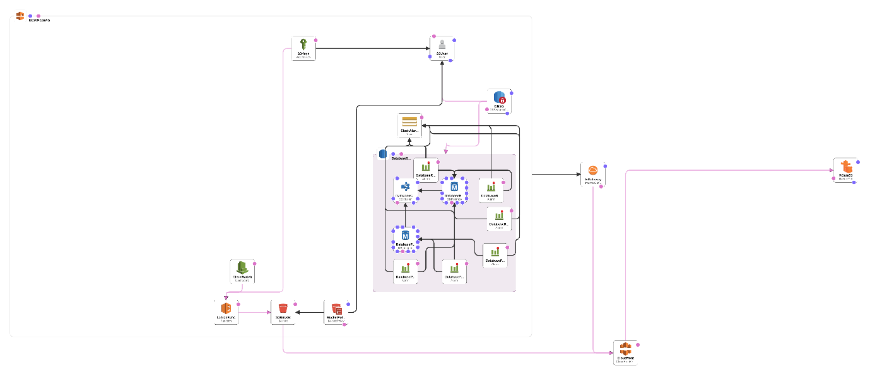

Thought Process –

* The entire system has to be encapsulated in a single VPC.
* The DB is Aurora MYSQL DB cluster has been designed inside a single Subnet group. DBSG is the security group for DB , which has been assigned to S3 user.
* For questions 3 and 4 : I have included AWS lamda , S3 bucket , Cloud watch (to capture the lamda function log).
* Source policy for AWS Lamda set up –
* I have assigned the cloud front front service to S3 bucket which will help to store the S3 WebPage componets in the edge servers and help to improve the latency ,loading and SEO of the webpage.
* In my second try I also created a EC2 linux box in AWS and deployed my PHP codes to build a demo.

I had to spend lot of time in taking the PHP web page up because the mysqli.so module was not getting uploaded in PHP 5.4

Challenges -

I had to configure , httpd and PHP in the EC2 box and could establish a connectivity with MY SQL RDS.

I did this activity to understand the process of hosting a webpage in AWS. It was a nice learning exercise.

* Study how to design CloudFormation templates –

This was somewhat new to me to design a template in the designer and create valid linking. I studied some sample templates and in the first go , I manually instantiated the services . It took some time for me to understand the Json format and how the file is designed. I took reference from the sample templates and tried to develop a design architecture.

* Writing the lamda functions – I am good in Python coding .However faced difficulty to upload python libraries to lamda function and test the codes. Hence I could not execute some of the portions of questions 3 and 4.

Aurora Database set up –

**For High Availability and better efficiency.**

**primaryinstance**

* StackAlarmTopic – Action This is the AWS simple Notification service which integrates the database alarms.

In the architecture I have set up three alarms as described below to ensure the high availability .

* DatabasePrimaryCPUAlarm "Threshold": 80, <80% more CPU> "Unit": "Bytes","Unit": "Percent",
* DatabasePrimaryMemoryAlarm "Threshold": 700000000 <Primary database freeable memory is under 700MB.> "
* DatabasePrimaryReplicationAlarm - "Threshold": 200, Database replication latency is over 200ms. Unit": "Milliseconds",

**DatabaseReplicaInstance**

* StackAlarmTopic – Action – This a SNS
* DatabasePrimaryCPUAlarm "Threshold": 90, <90% more CPU>
* DatabasePrimaryMemoryAlarm "Threshold": 700000000 <Primary database freeable memory is under 700M>
* DatabasePrimaryReplicationAlarm - "Threshold": 200, Database replication latency is over 200ms.

**For RDS auto scaling -**

I have assigned the primary DB and Replica DB on a single cluster and controlling the autoscaling by property **scalingConfigaration**

"ScalingConfiguration": {

"AutoPause" : 1, <cost effective>

"MaxCapacity" : 128,

"MinCapacity" : 32,

"SecondsUntilAutoPause" : 250

},